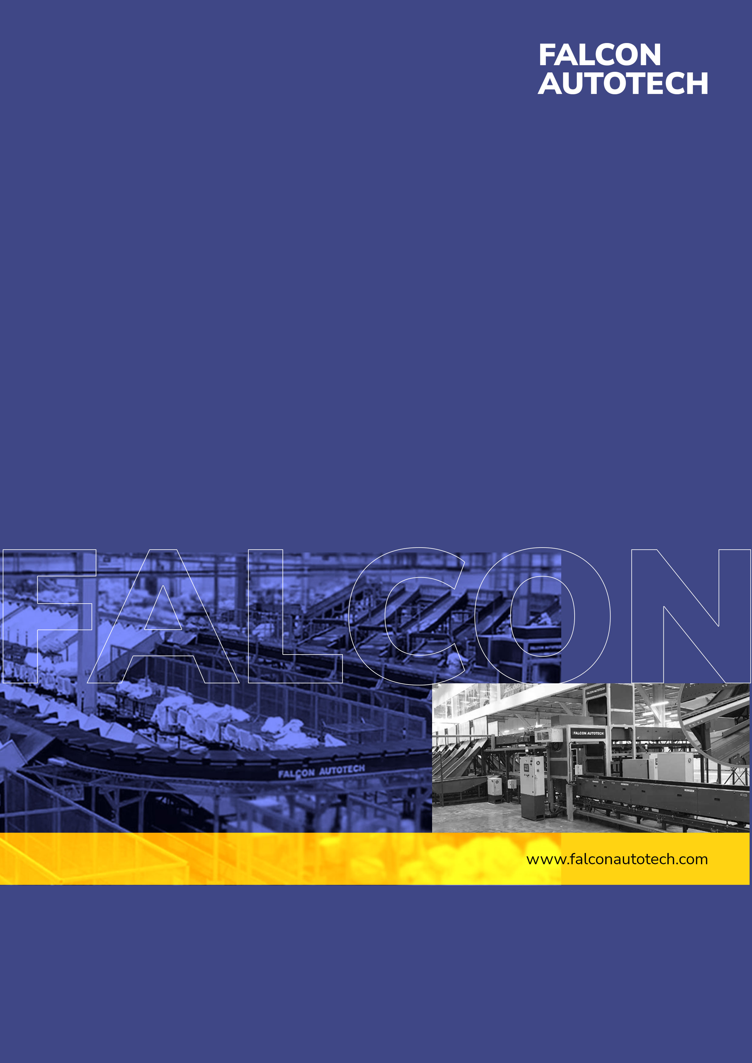

FALCON’s Response to
Flipkart for the supply of Modified ARB VDS
May 4, 2023

Kind Attention –

Mr. Susheel Kumar Singh

M/s Flipkart

Offer Ref: F23-00267; Date 14.03.2023.

Subject – Techno -Commercial Offer of modification in ARB VDS.

Dear Sir,

We are pleased to submit our Techno-Commercial Offer in response to your RFQ
As you will note, we have studied your challenges in current process, We have collected required details during the workshops and calls with you, we have put together a detailed technical proposal laid out in various sections and sequenced to enable you to understand our proposed solution and to re-enforce our commitment to be your partner in this strategic initiative.
In subsequent sections, we have highlighted the capabilities and experiences of Falcon Autotech with sections on our Automation Technologies and references.
To conclude, I would like to add my personal commitment, on behalf of Falcon Autotech. As we move through the RFP process, please do not hesitate to contact me and my team. We will be pleased to assist you for any further information or clarifications that you might have.
Contact Person : Sanyog Pratap Singh
Title : Assistant Manager
Mobile : +91-8750052591
Email : Sanyog.singh@falconautoonline.com

Company Details
Company Name : Falcon Autotech Pvt. Ltd.
Regd. Office : 57, Nimri Colony, Double Storey Flats, Delhi – 110052
Website : www.falconautotech.com
LinkedIn : linkedin.com/in/animesh-agarwal-94b40916

Contents
1. Proposed System Description 4
a. Objective 4
b. Proposed changes 4
5. System description 5
a. ARB Belt 5
2. Proposed System Technical Details 6
a. Mechanical equipment 6
3. Key Components Make 6
4. Program Organisation 6
5. Commercial Terms 7
a. Price Sheet 7
b. Payment Terms 8
6. Exclusions 9

Proposed System Description

Objective
To modify existing ARB based VDS to enhance performance.
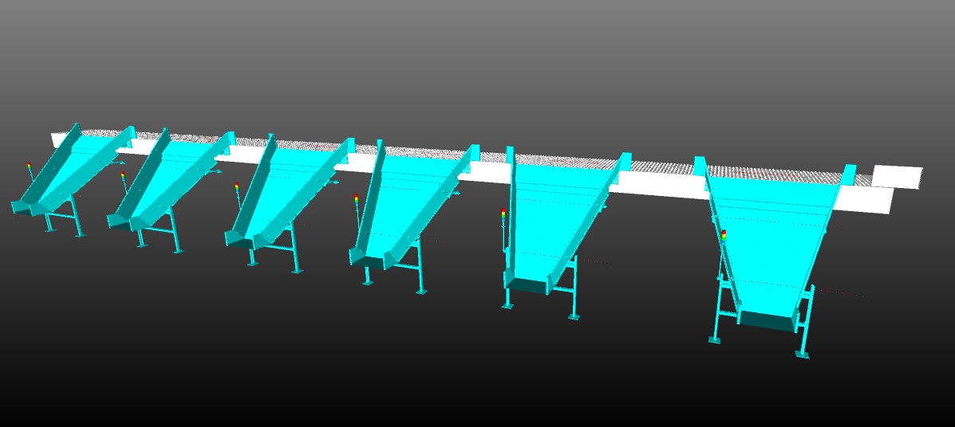

Proposed changes

- Changing existing ARB Belt
- Replacing existing flat UHM strips with grooved UHM strips
- Replacing the existing motors
- Modification of Infeed conveyors- Existing conveyor converted into 2 modules-
  - 3 m of conveyor module with holes added.
  - Length of existing conveyor reduced.

Note :

All the above suggestions recommended by OEM are not yet tried at any of the Falcon sites, so the result is subject of realization and observation. So, Falcon will guaranty that by this modification how much life of the belt can be increased.

System description

ARB Belt
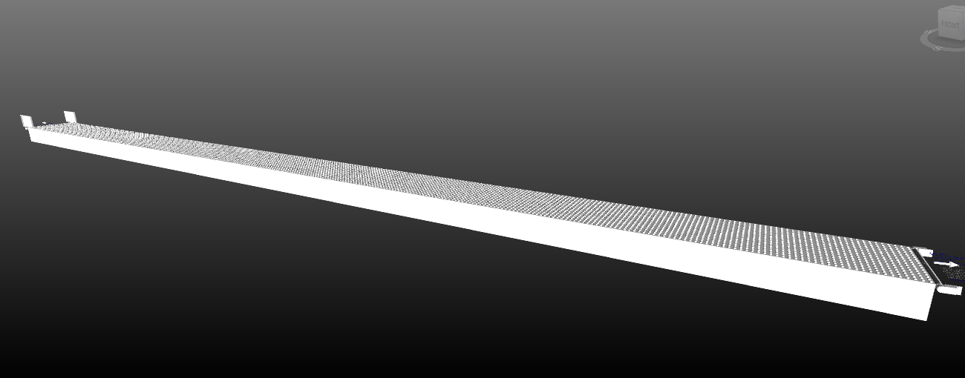

Legend
1- ARB belt conveyor

Proposed System Technical Details

Mechanical equipment

S.no. | Qty. | Description | Value
1 | 1 | ARB conveyor  Activated roller belt Conveyor – 2 x 24.25 m | ~1200 mm width
2 | 1 | Grooved UHM Strips | Included
3 | 1 | 2 Nos Drive motors | Included
4 | 1 | Special Conveyor with holes – 2 x 3 m | Included

Key Components Make

Items | Make
ARB conveyor | Movex
UHM Strips | Falcon

Program Organisation

1.Program/ Project Schedule
14-16 weeks Ex- works Greater Noida .

Commercial Terms

Price Sheet
S. No | Component | Set | Price (INR)
1 | ARB Modification | 1 | ₹ 88,72,027
2 | Dismantling, Installation & Commissioning | 1 | ₹ 8,43,601
3 | Packaging & forwarding | 1 | ₹ 1,77,441
4 | Project Management and Engineering Charges | 1 | ₹ 2,37,327
Total (INR) |  |  | ₹ 1,01,30,395

The Total Price is to be understood.
- Freight- Excluded
- GST will be charged extra @ 18%
- Including Packing and Forwarding
- Dismantling, Installation and Commissioning: Included
- Price is valid for 60 days from the date of proposal.
- Dismantled material will be stored at FK suggested place in the Facility. Packing of this material will not be in Falcon’s Scope.
*Material Unloading & Laydown area is in customer scope

Payment Terms
Agreed payments terms for earlier projects.

Warranty Period
Falcons offered System comes with a standard warranty of 1 year (Starts from the date of beneficiary use) and post completion of warranty, customer can opt for Extended warranty. Warranty covers the following support:
- 24 X 7 Telephonic, Email and Remote Service Support when required.
- Regular Software updates and Bug Fixes.
- Supply of Mechanical and Electrical components in case of failure (excluding damages as mentioned in Exclusion Clause)
The warranty does not apply to replacement or repair of:
- Normal wear and tear.
- Consumables.
- Faulty articles continued:
  - Failure to comply with the manufacturer's recommendations (logistics documentation, Technical Information Note, retrofit document) and the rules of the trade.
  - Negligence or abnormal use of equipment.
  - Anomalies produced by an environment of use, storage or transport that does not comply with the specifications or recommendations of Falcon: packaging, temperature, hygrometry, sector, insulation, etc.
  - A defect due to a cause external to the supplies and services of Falcon.
- Equipment other than that supplied by Falcon.
- Items that can be repaired exclusively by Falcon that have been repaired or attempted repairs other than those carried out by Falcon.
- Items that fail due to normal wear and tear of one or more of its components or whose tamper-evident seals (varnish, strip, etc.) have been broken or whose serial numbers have been removed or modified.
- Items damaged during transport to Falcon due to the use of unsuitable packaging.

Exclusions

The scope of supply includes all parts which are defined in the Supplier’s quotation.

All other parts which are not defined in the Supplier’s quotation do not belong to the Supplier’s scope of supply and are excluded. The following parts are also excluded:

- Server PC & Server Rack
- Steel Works- If not specified
- Building infrastructure; building structure, doors, fire exits, levelling devices, building extinguisher and fire alarm system, building heating and lighting system.
- Electrical power supply and wiring to the main control cabinets
- UPS for Controls and Drives
- Network Cabling up to the Main Server Rack
- Intermediate wiring to parts which are to be supplied by the Purchaser/others
- Emergency/Uninterruptable power supply
- Fire-alarm and fire protection devices
- Traffic and route markings
- Laydown Area
- Ram protection devices
- Cat walks, bridges, maintenance aisles and platforms
- Assembly tools like forklifts and hoisting machines
- All kind of network incl. Local Area Network (LAN/WLAN), exceeding the scope described in Scope of Supply
- Any Kind of Civil work
- Any adjustment of the Supplier’s scope of supply to local rules and regulations
- X-Ray machines
- Roller cages/ Pallets
- Simulation and 3D animation of the sorter system
- Interface with other equipment not specified in this offer.
- Provision of facilities for the control room (furniture, air conditioning, heating, etc.).
- The supply and installation of fencing around the different corridors.
- Any item specifically indicated as not forming part of the subject matter of the Seller's supply in the offer documentation.

